Assignment 2

1. Write a java program to calculate Fibonacci Series.
2. public class Fibonnaci {
3. public static void main(String[] args) {
4. int n1=0, n2=1, n3=0;
5. int n=Integer.parseInt(args[0]);
6. System.out.print(n1 + " " + n2);
7. for(int i=1; i<n-1; i++){
8. n3=n1+n2;
9. n1=n2;
10. n2=n3;
11. System.out.print(" "+ n3);
12. }
13. }
14. }

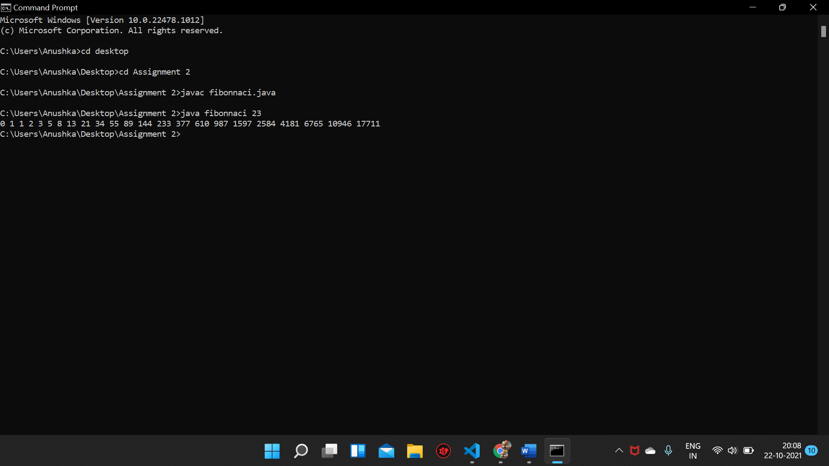

2. Write a program to check of the given number is palindrome or not.

public class Palindrome {

    public static void main(String[] args) {

        int n=Integer.parseInt(args[0]);

        int t=n, rev=0;

        while(t>0){

            rev=rev\*10 + t%10;

            t/=10;

        }

        if(rev==n){

            System.out.println("The given number is a palindrome");

        }

        else{

            System.out.println("The given number is not a palindrome");

        }

    }

}

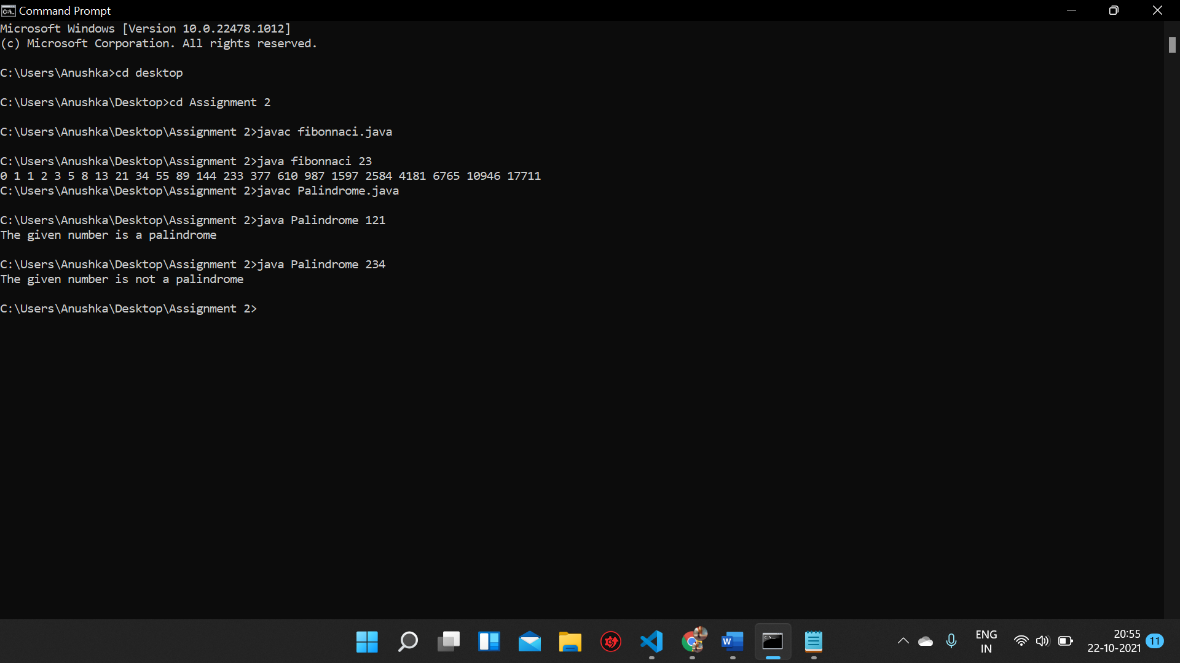

3. Write a java program to check whether the number is prime or not

public class Prime {

    public static void main(String[] args) {

    int n=Integer.parseInt(args[0]);

    int count=0;

    for(int i=2; i<n; i++){

        if(n%i==0){

            count++;

        }

    }

    if(count==0){

        System.out.print("The number is prime.");

    }

    else{

        System.out.print("The number is not prime.");

    }

    }

}

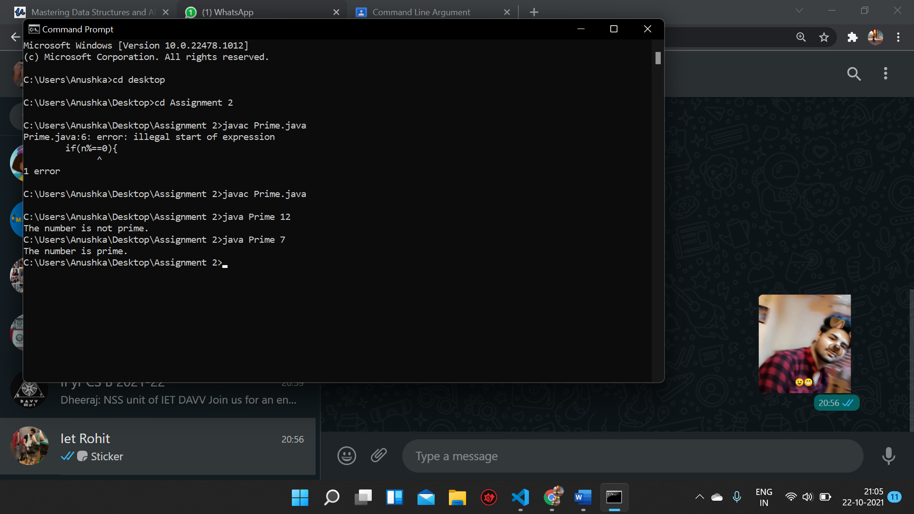

4. Write a java program to check whether the number is Armstrong

Number

public class Armstrong {

    public static void main(String[] args) {

    int n=Integer.parseInt(args[0]);

    int t=n, arm=0;

    while(t>0){

        int k=(t%10)\*(t%10)\*(t%10);

        arm+=k;

        t/=10;

    }

    if(arm==n){

        System.out.print("The given number is an armstrong number");

    }

    else{

        System.out.print("The given number is not an armstrong number");

    }

    }

}

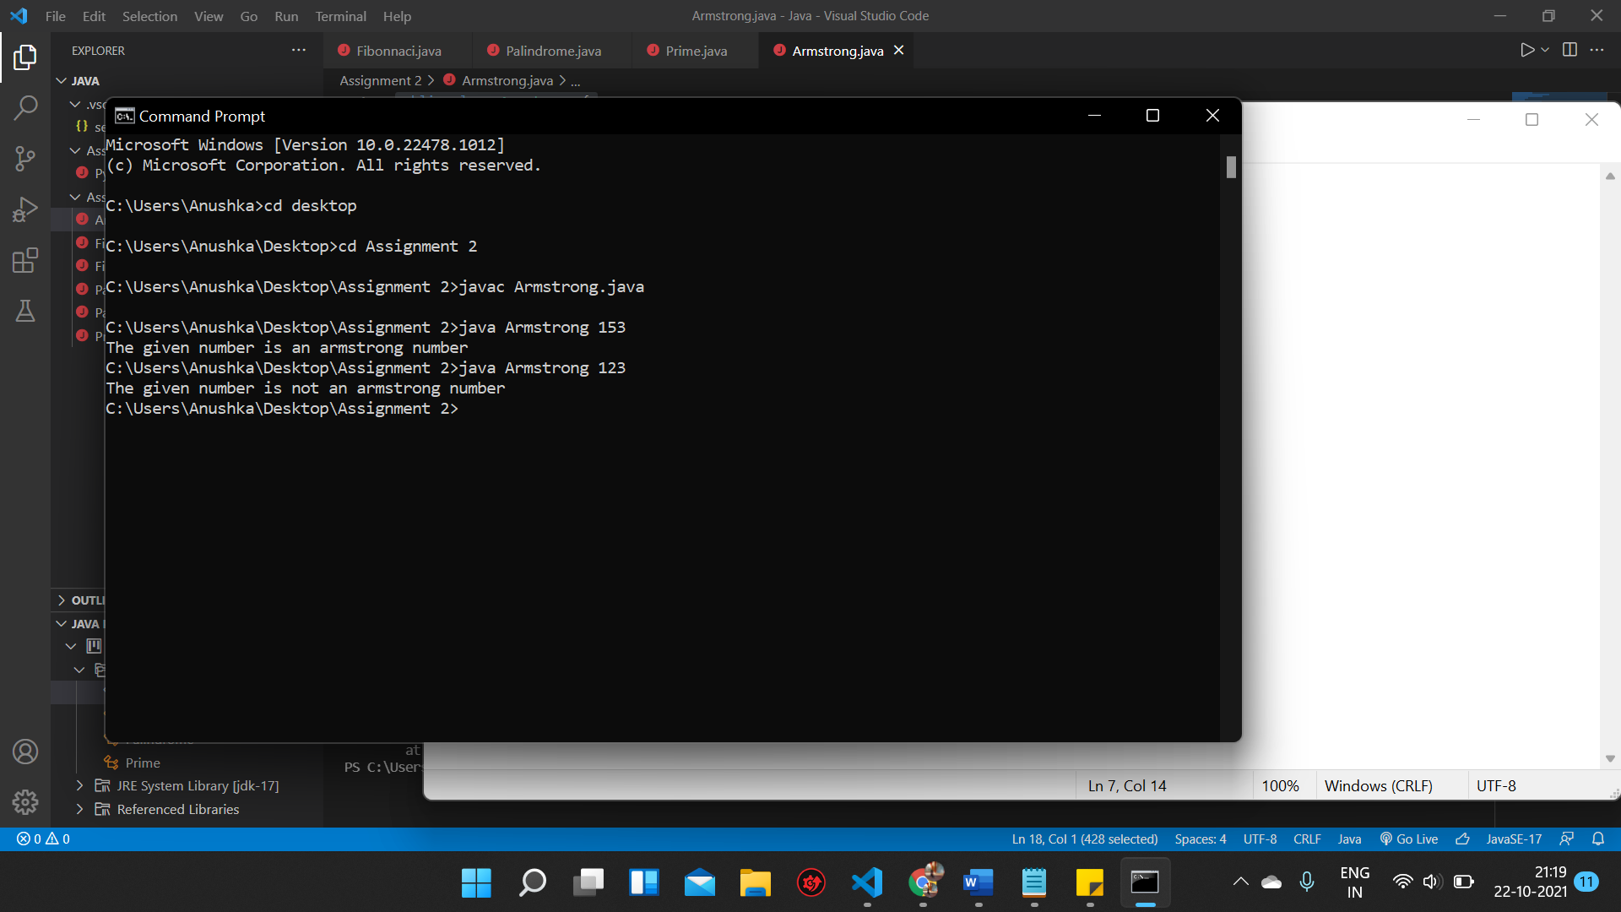

5. Write a java program to display a message according to marks

obtained by student

public class Marks {

    public static void main(String[] args) {

    int n=Integer.parseInt(args[0]);

    if(n>=35){

        System.out.print("You have passed the exam.");

    }

    else{

        System.out.print("You have failed the exam.");

    }

    }

}

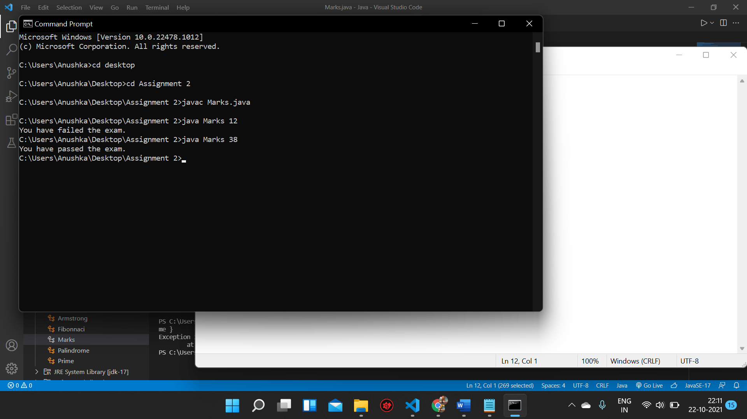

6. Write a java program that will read a float type value from the

keyboard and print the following output:

➢ Small integer not less than the number

➢ Given number

➢ Largest integer not greater than number

public class GIFLIF{

public static void main(String[] args) {

    float n=Float.parseFloat(args[0]);

    int gif=(int)n;

    int lif=(int)n+1;

    System.out.println("The smallest integer not lesser than the number is " + lif);

    System.out.println("The givem number is " + n);

    System.out.println("The largest integer not greater than the number is " + gif);

    }

}

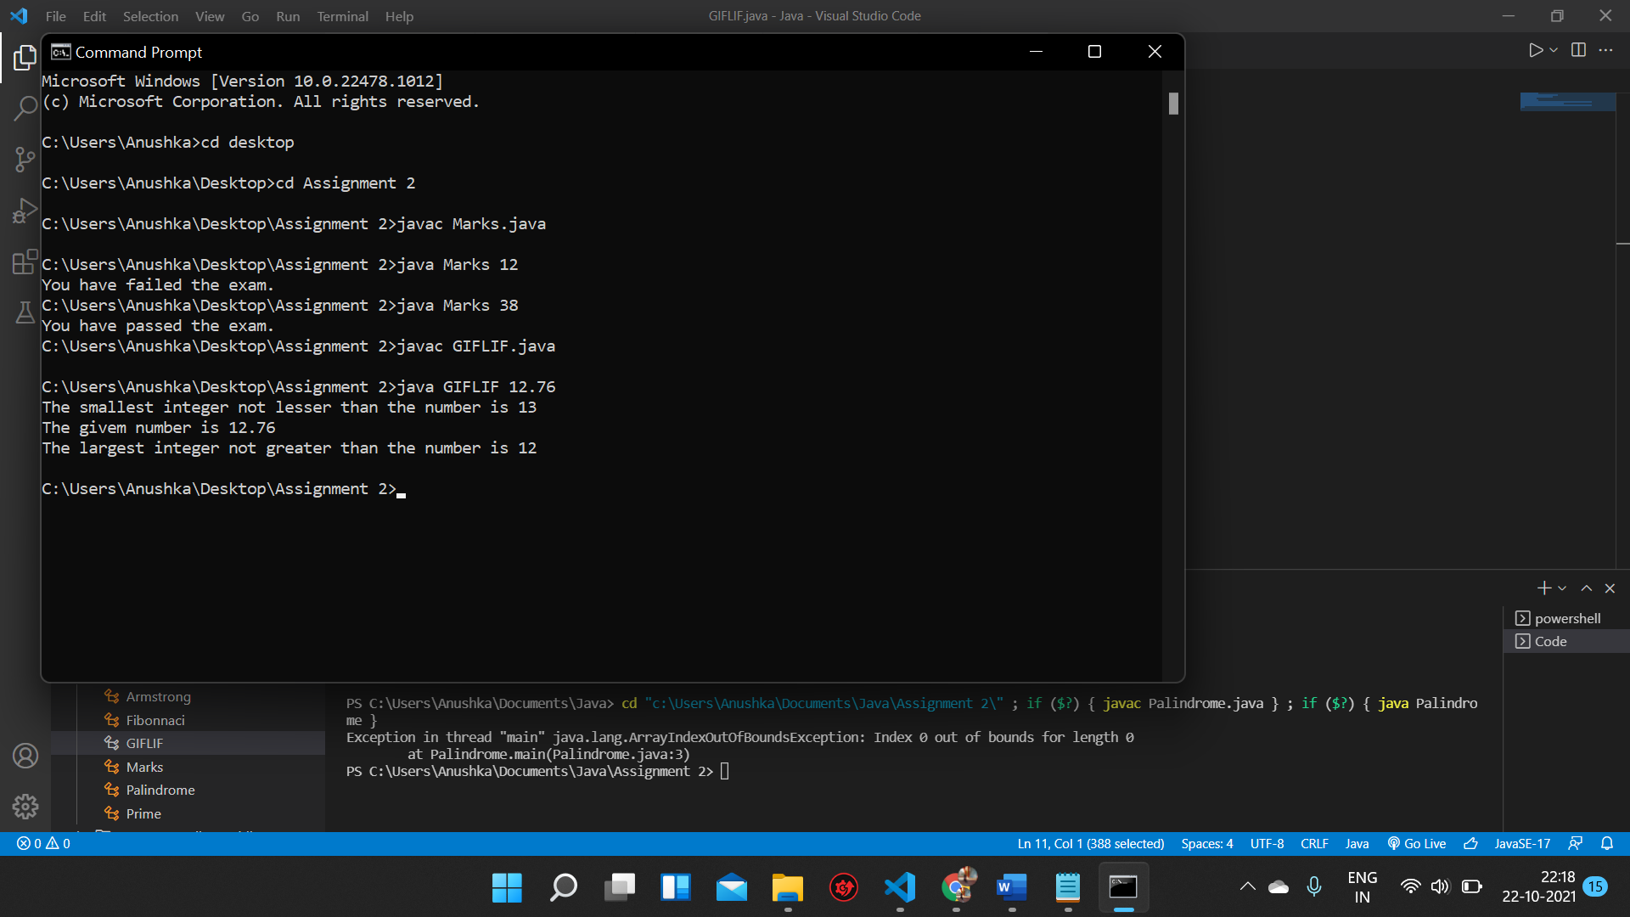

7. Write a Java program to sort a numeric array and a string array.

Import java.util.\*;

public class SortArray {

    public static void main(String[] args) {

    int n=Integer.parseInt(args[0]);

    //Numeric array

    int[] array1;

    array1= new int[n];

    for(int i=0; i<n; i++){

        int term=Integer.parseInt(args[i+1]);

        array1[i]=term;

    }

    Arrays.sort(array1);

    System.out.print("The sorted numeric array is: ");

    for(int i=0; i<n; i++){

        System.out.print(array1[i] + " ");

    }

    System.out.println();

    //String array

    String[] array2;

    array2= new String[n];

    for(int i=0; i<n; i++){

        String term= args[n+i+1];

        array2[i]=term;

    }

    Arrays.sort(array2);

    System.out.print("The sorted string array is: ");

    for(int i=0; i<n; i++){

        System.out.print(array2[i] + " ");

    }

    }

}

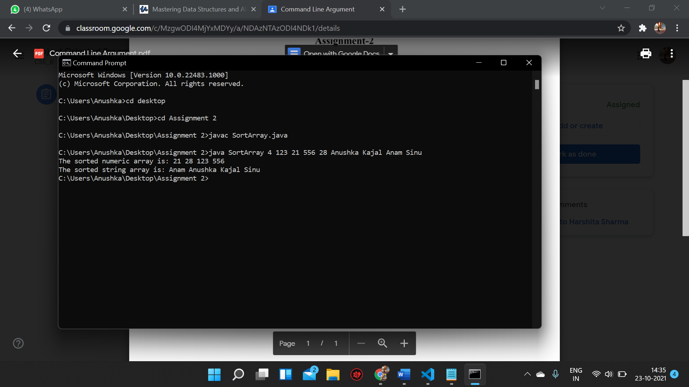

8. Write a java program to find the sum and product of an entered

number.

public class SumProduct {

public static void main(String[] args) {

    int n=Integer.parseInt(args[0]);

    int sum=0, product=1;

    while(n>0){

        sum+=n%10;

        product\*=n%10;

        n/=10;

    }

    System.out.println("Sum of digits is: " + sum);

    System.out.println("Product of digits is: " + product);

    }

}

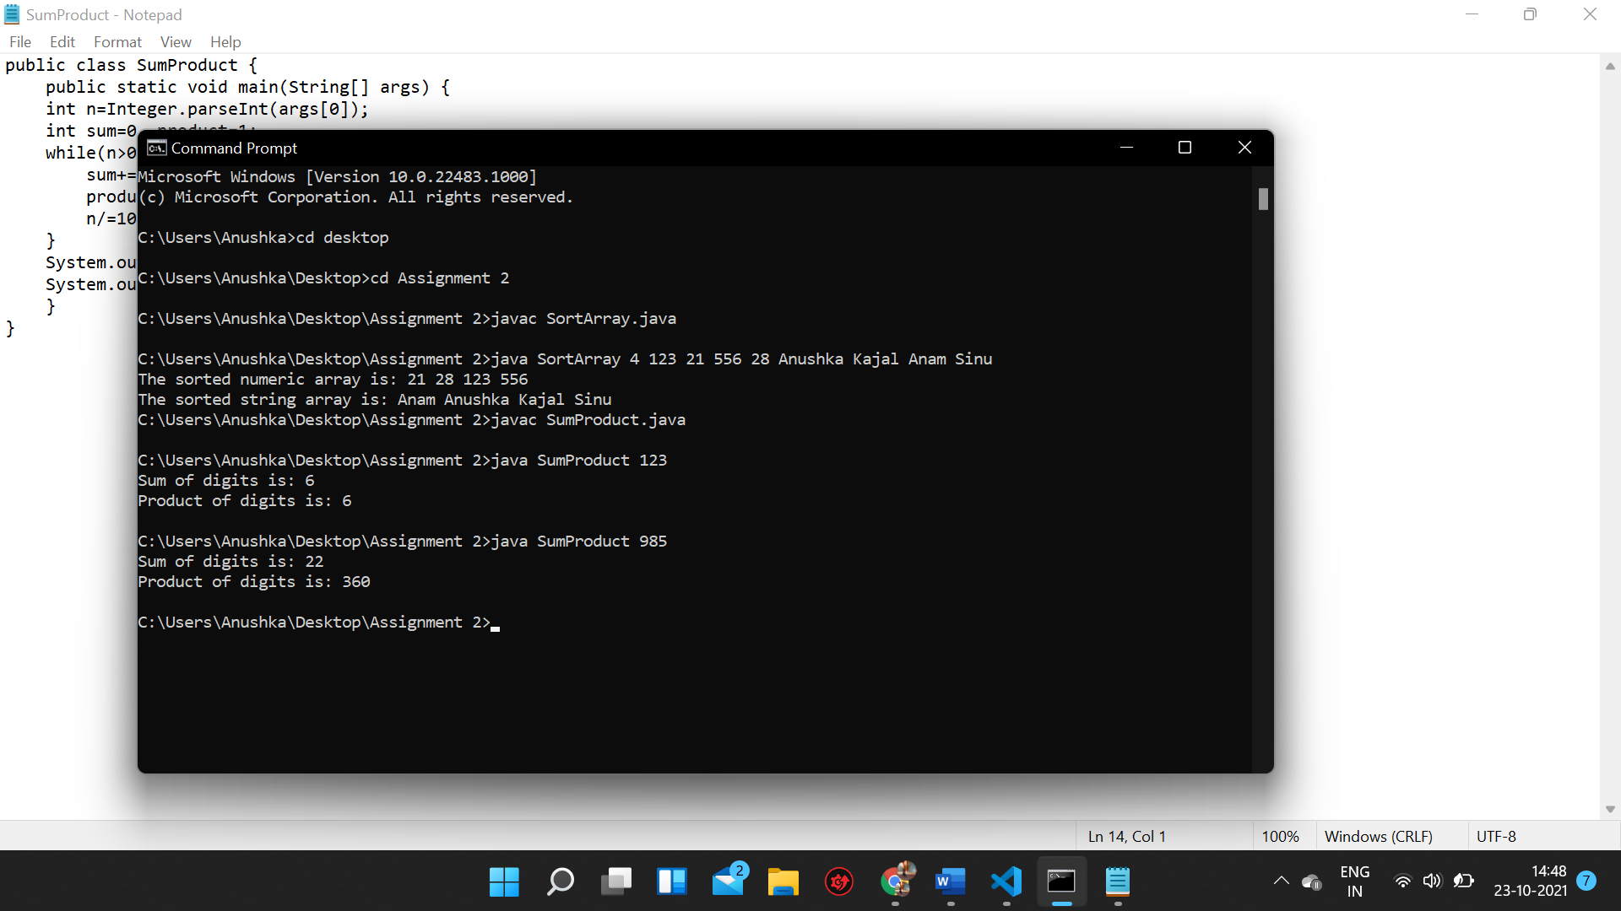

9. Write a Java program to find the common elements between two

arrays (string values).

public class CommonString {

public static void main(String[] args) {

    int num1=Integer.parseInt(args[0]);

    int num2=Integer.parseInt(args[1]);

    int common, count=0;

    if(num1>num2)

        common=num2;

    else

        common=num1;

    String[] s1=new String[num1];

    String[] s2=new String[num2];

    String[] s3=new String[common];

    for(int i=0; i<num1; i++){

        String term= args[i+2];

        s1[i]=term;

    }

    for(int i=0; i<num2; i++){

        String term= args[num1+i+2];

        s2[i]=term;

    }

    for(int i=0; i<num1; i++){

        for(int j=0; j<num2; j++){

            if(s1[i].equals(s2[j])==true){

                s3[count]=s1[i];

                count++;

            }

        }

    }

    System.out.println("Number of common elements are: " + count);

    System.out.println("The common elements are ");

    for(int i=0; i<count; i++){

        System.out.print(s3[i]+ " ");

    }

    }

}

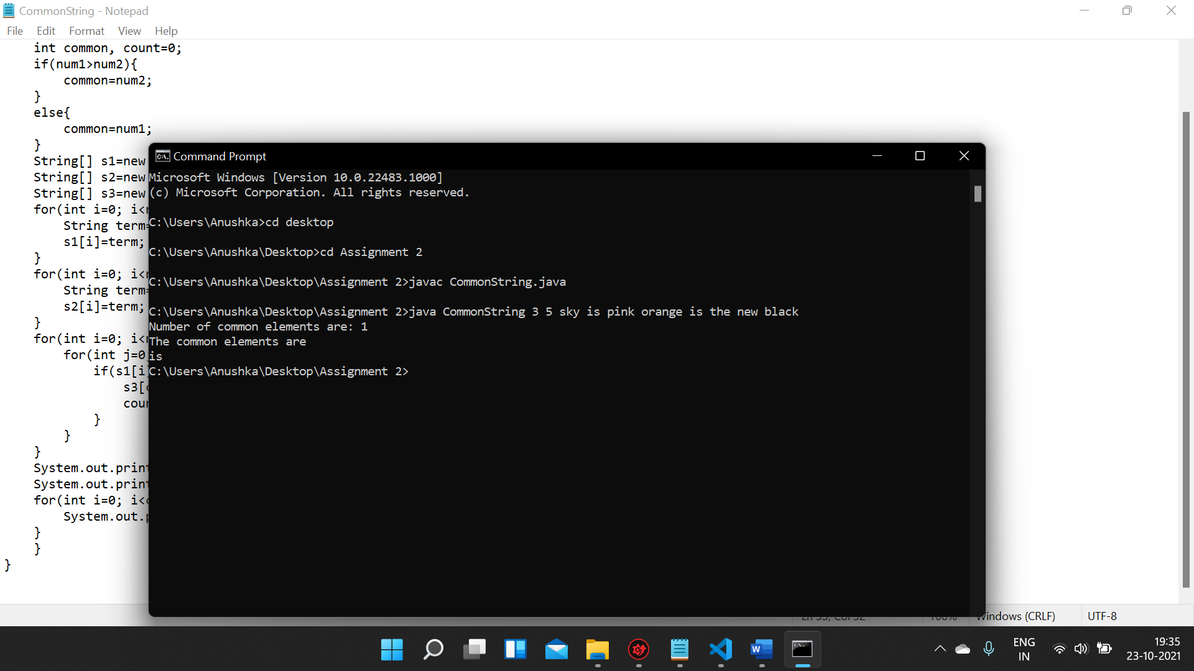

10. Write a Java method to compute the future investment value at a

given interest rate for a specified number of years.

public class SimpleInterest {

    public static void main(String[] args) {

    int rate=Integer.parseInt(args[0]);

    int principle=Integer.parseInt(args[1]);

    int time=Integer.parseInt(args[2]);

    int si= (rate\*principle\*time)/100;

    System.out.println("The total value is " + si);

    }

}

